IHE Work Item Proposal (Detailed)

# Proposed Work Item: < Reconciliation on FHIR>

**Proposal Editor:** Emma Jones, George Cole

**Work item Editor:** Emma Jones, George Cole

**Date:** November 11, 2014

**Version:** draft 2

**Domain:** Patient Care Coordination (PCC) Technical

**Summary**

Reconciliation of clinical information is a task that occurs during every new admission, consultation and discharge or transfer/transition of care. Patients with complex medical history can have dozens of care plan related issues, making it extremely difficult for healthcare providers to keep track of and audit the relevant information. During the process of collaborative care, the results of reconciliation need to be communicated to support the longitudinal paradigm needed for safe patient care.

As shown in this diagram, IHE RECON profile provided the ability to communicate that reconciliation of clinical content and care providers could be accomplished with any CDA constructed list regardless of implementation guide.

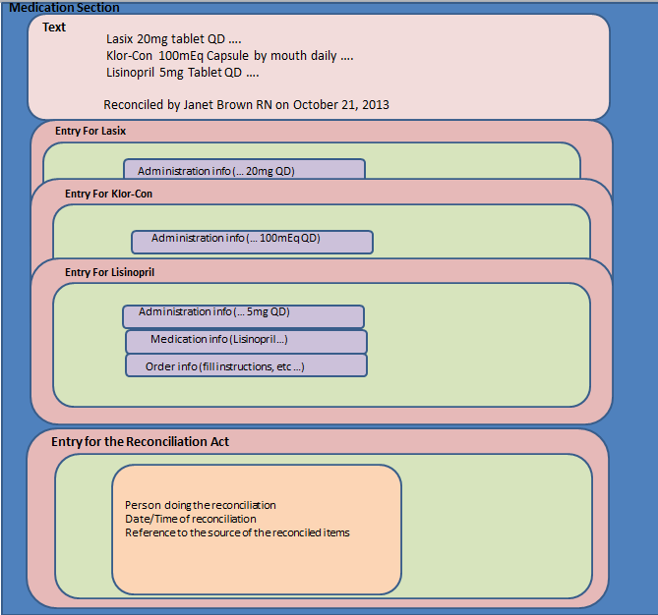

The need for reconciliation of clinical content was requested during HL7 first FHIR Clinical Connectathon (Sept 2014). This proposal is to provide the ability to communicate reconciliation of clinical content and care providers using FHIR constructs.

# The Problem

IHE Reconciliation of clinical content and Care Provider Profile enables the ability to communicate that reconciliation has occurred, when it happened and who did the reconciling as a component of clinical workflow.

As the interoperability community explore and adopt the use of FHIR, the ability to reconcile and consolidate data should be maintained. This proposal will identify and define what is needed to assist with the heavy lifting making it easier for human intervention using FHIR Resource. The intent of this profile is not to replace human action, but is meant to augment and assist in the act of reconciling and consolidating clinical information.

IHE provided the ability to electronically reconcile and consolidate clinical content and care provider data as well as communicate this information using CDA constructs. This profile will provide the same workflow needs using FHIR constructs.

# Use Cases

Integration Problem Use Case:

Clinician receives Care Plan information in home health EHR from two different providers about the same patient. Patient is post hip replacement surgery. Activity intervention from provider A (Primary Care Provider) is bed rest, turn Q2 hrs with assistance due to right hip fracture. Provider goal is to prevent skin breakdown. Activity intervention from provider B (Orthopedic Surgeon) is for patient to ambulate TID utilizing a walker status post total right hip replacement surgery. Provider goal is to increase patient ambulation at least ten feet with a walker. Manual reconciliation and consolidation is needed to determine which activity intervention, goal and care provider is the most appropriate for the patient at this time.

How it should work Use Case:

Home Health clinician receives Care Plan information in home health EHR from two different providers about the same patient. Patient is post hip replacement surgery. Activity intervention from provider A (Primary Care Provider) is bed rest, turn Q2 hrs with assistance with goal to prevent skin breakdown. Activity intervention from provider B (Orthopedic Surgeon) is for patient to ambulate TID utilizing a walker with goal of ambulating at least ten feet utilizing a walker.

Upon receipt of the two different ambulation intervention, goal and provider information, the home health EHR determines which intervention and goal is the most recent. The home health EHR also compares indication for both interventions and goals and determines which is the most recent. All information is presented to the user. User is better able to determine the intervention, goal and care provider that are most appropriate for the patient at this time or if follow-up with the provider(s) is required. User performs the reconciliation actions and is able to communicate that reconciliation occurred.

# Standards & Systems

**Existing Systems:**

* Primary Care Physician’s EHR
* Specialist Physician (Orthopedic Surgeon) EHR
* Home Health EHR
* Hospital EHR
* Care Management EHR
* HIE Systems
* PHRs

**Applicable Standards:**

* + HL7 Patient Care and Service Oriented Architecture Work Groups Care Plan Reconciliation Project
  + Content
    - FHIR
    - HL7 Patient Care DAM
    - IHE RECON Profile
    - CDA Medical Summary Document
    - CCDA
    - HL7 Version 2, 3
    - HL7 CDA Release 2
  + Vocabularies
    - LOINC
    - SNOMED
    - HL7
    - Etc.

# Technical Approach

* Map IHE RECON constructs to FHIR constructs, identifying gaps and needed changes.
* Define FHIR profile/resources that supports reconciliation workflow

**New actors**

No new IHE actors. May need new FHIR profile/resource.

**Existing actors**

No IHE existing actors will be affected by this profile. May need to modify existing FHIR profile/resource

**New transactions (standards used)**

No new transactions needed.

**Impact on existing integration profiles**

No existing IHE integration profiles will need to be modified.

**New integration profiles needed**

No new integration profiles needed.

**Breakdown of tasks that need to be accomplished**

* Follow IHE/HL7 collaborative process (including other possible HL7 co-sponsors)
* RECON to FHIR mapping – gap analysis
* Modify FHIR constructs as needed to support reconciliation workflow- use HL7 Patient Care group for input
* Define needed FHIR constructs

# Risks

* IHE/HL7 collaborative process
* Technical resources needed from FHIR
* Current IHE RECON profile is untested – may have changes coming with current Connectathon testing
* Insufficient HL7 patient care review

# Open Issues

* IHE/HL7 collaborative process

# Effort Estimates

<The technical committee will use this area to record details of the effort estimation.>